**Docker Task3**

1. Write a note on Dockerfile with usage of its attributes.
2. What is difference between CMD and ENTRYPOINT?
3. Write a Dockerfile to run Nodejs application build an image from it and create a container using that image (also include persistent volume and network in Dockerfile).

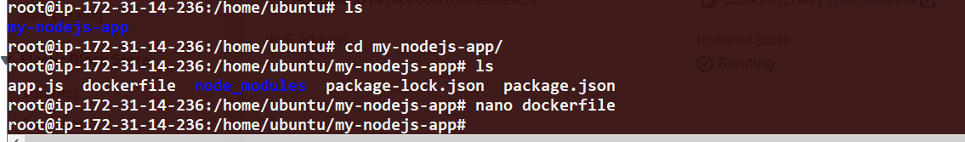

Docker build –t dockerfile .

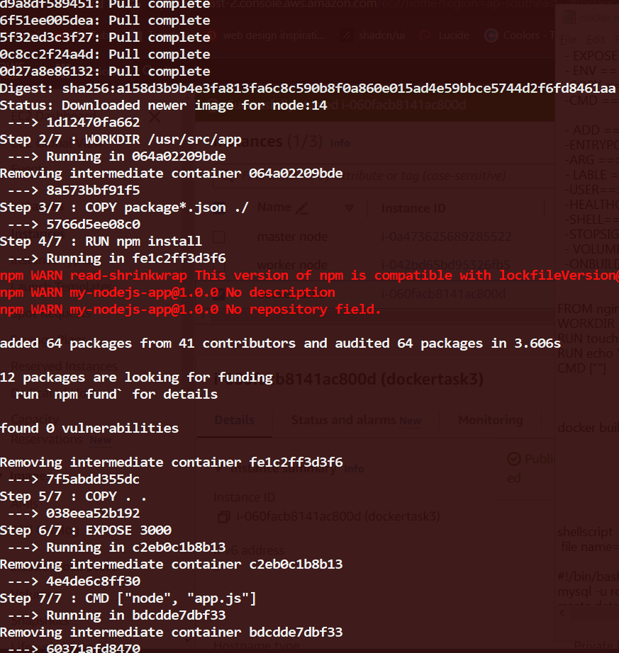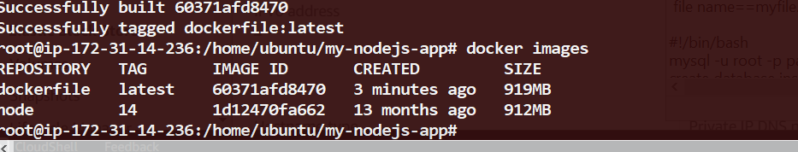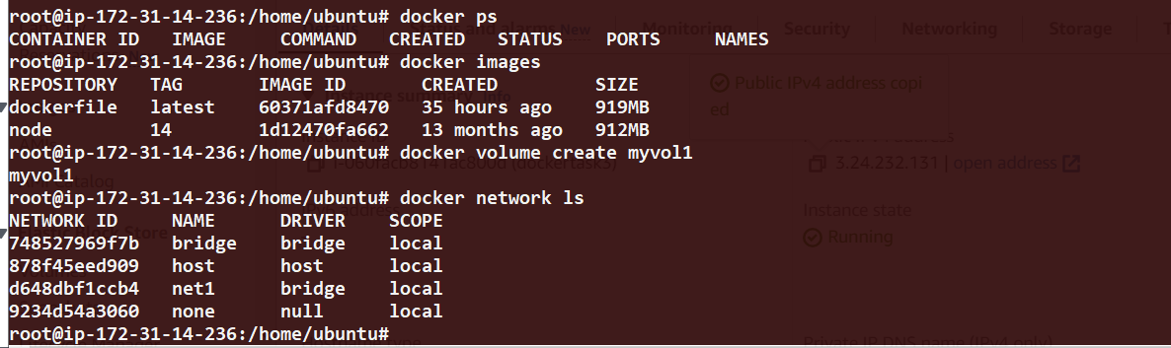



1. Write a Dockerfile to create a python application build image from it and push that image to private repository of Docker hub.



Docker build –t my_python –f pyfile .

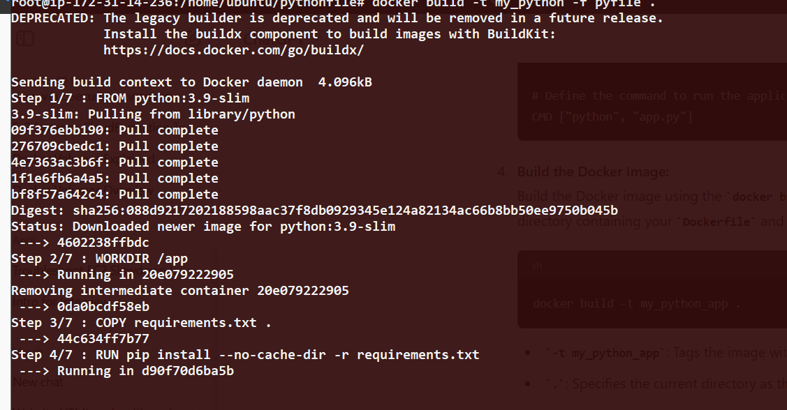

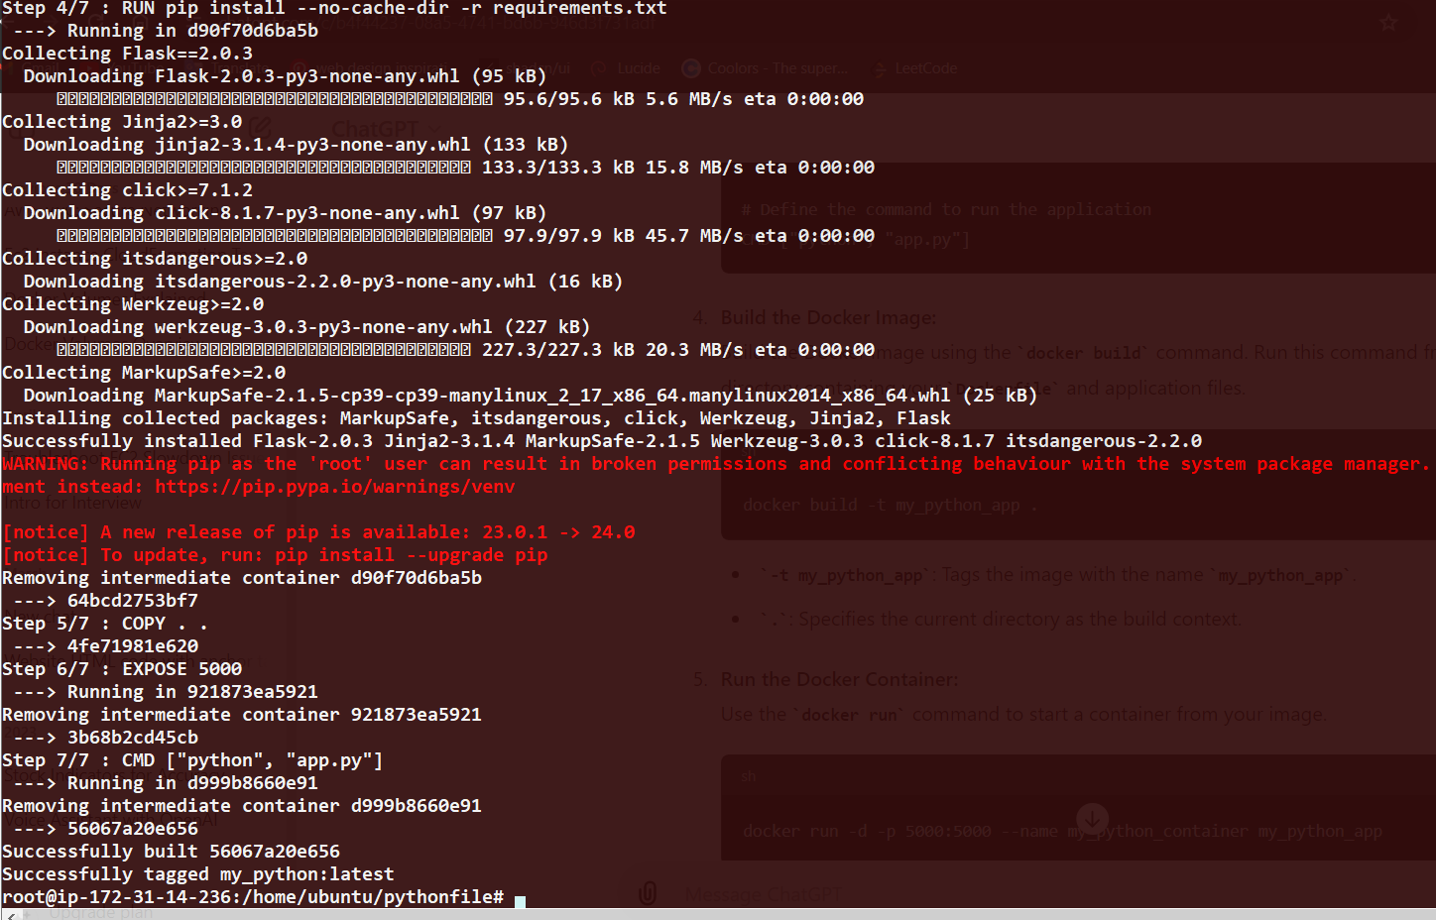

docker tag my_python omidocker1885/omireppoo:my_python

